Fake Media mitigation via blockchain
A platform for mitigating the spread of fake media.

Executive Summary

Due to the spread of social media in the digital era, many people are capturing photos and videos of their real-life events, on the other hand faking photos and videos become extremely easy in a scary way.
Our aim is to develop an interactive platform that helps people to validate photos and videos of real-life events. A user simply takes a photo or a video of an event or an accident, then the media file will be uploaded to our platform, other users within the area will review the media file and based on its Genuity they will up or down vote, depending on the up or down votes the media file had received. it will be stored or deleted permanently on our platform. thanks to smart contract and Blockchain it will be impossible to alter the media file after storing it on our platform. Figure 1 roughly describes the idea.

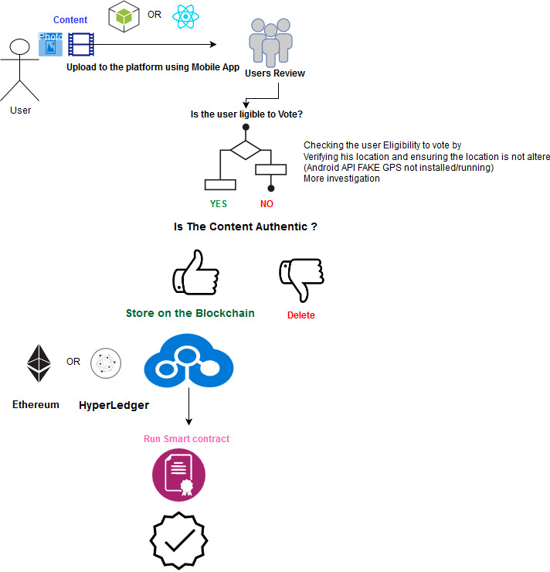
Figure 1 A walk through our platform

Technical aspects
1- A mobile App either using Android or a cross-platform ie React native will be developed, that allows the user to capture, upload and view photos/videos, furthermore it will permit the user to participate in the voting system to validate media files captured by other users.
2- A back-end server will be used to check the votes and store the media files with its timestamp and votes. We will run smart contracts on media files that will either store or delete based on the previously mentioned voting phase.
Preliminary Key findings:
- UID: A unique user identification for every single device either the user could anonymously login based on its device unique id
- In addition user could sign in
- Raw Data: Photos Videos Audio files.
- GPRS: Using GPRS of the mobile device in order to check if the user is within a specific location area, thus the user is able to participate in the voting phase. Fake GPS should be taken into consideration to increase the reliability of our platform, as a result, only users within a specific radius can participate in the voting phase. This could be achieved through the app by checking if the fake location service is not running or installed.
- WLAN RSS Database: Using WLAN for Fingerprinting coordinates.
- Time: Media files will be stored with the timestamp.

